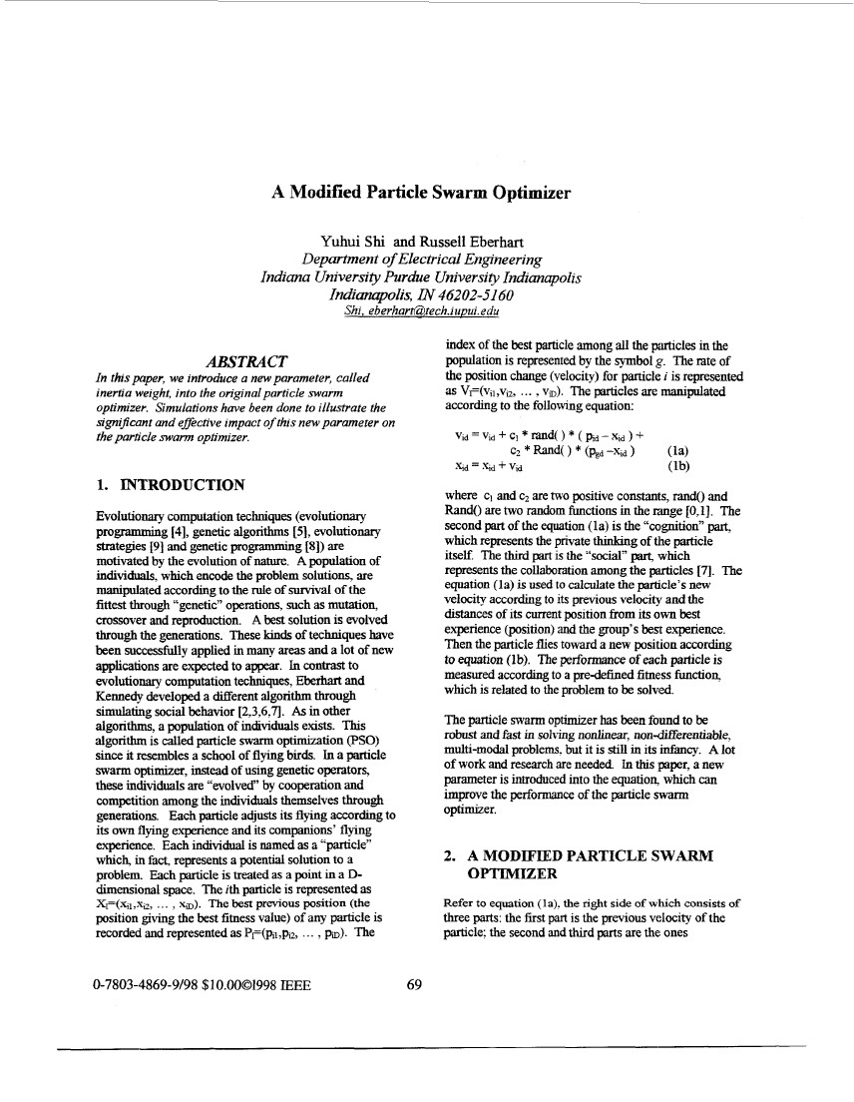
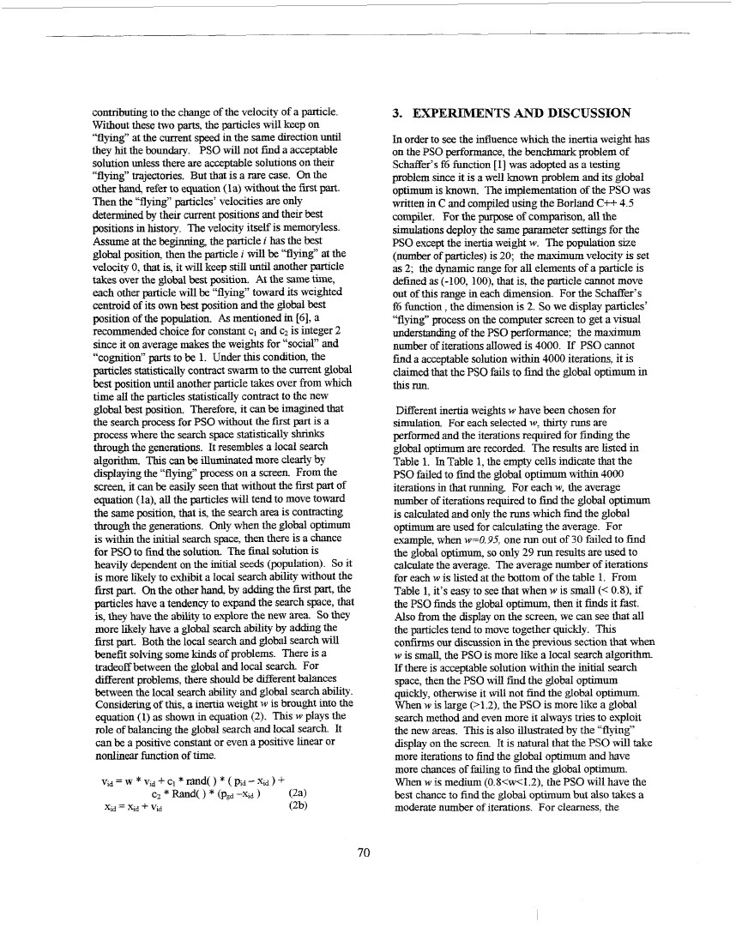
A Modified Particle Swarm Optimizer
Yuhui Shi and Russell Eberhart
Department o Electrical Engineeringf
Indiana University Purdue University Indianapolis
hdianqolis, IN 46202-5160
Shi. eberhart@,tech.iuEnti.edu
ABSTRACT
In this paper, we introduce a new parameter, called
inertia weight, into the original particle swarm
optimizer. Simulations have been done to illustrate the
signilicant and effective impact of this new parameter on
the particle swarm optimizer.
index of the best parhcle among all the particles in the
population is represented by the symbol g . The rate of
the position change (velocity) for particle i is represented
as Vf(vil,viz, ... ,VD). The particles are manipulated
according to the following equation:
1. INTRODUCTION
Evolutionary computation techniques (evolutionary
programming [4], genetic algorithms [5], evolutionary
strategies [9] and genetic programming [SI) are
motivated by the evolution of nature. A population of
individuals. which encode the problem solutions. are
manipulated accordingto the rule of survival of the
fittest through “genetic” operations, such as mutation,
crossover and reproduction. A best solution is evolved
through the generations. These kjnds of techniques have
been successfully applied in many areas and a lot of new
applicationsare expected to appear. In contrast to
evolutionary computation techniques, Eberhart and
Kennedy developed a different algorithm through
simulatingsocial behavior [2,3,6,7J As in other
algorithms,a population of individuals exists. This
algorithm is called particle swarm optimization (PSO)
since it resembles a school of flying birds. In a particle
swarm optimizer, instead of using genetic operators,
these individuals are “evolved” by cooperation and
competition among the individuals themselves through
generations. Each particle adjusts its flying accordingto
its own flying experience and its companions’ flying
experience. Each individual is named as a “particle”
which, in fact, represents a potential solution to a
problem. Each particle is treated as a point in a D-
dimensional space. The ith particle is represented as
X ~ ( x , ~ ,.x ~ x~). The best previous position (the_, ,_
where c and c2are two positive constants, rand() and1
Rand() are two random functions in the m g e [0,1]. The
second part of the equation (la) is the “~~gnition”part,
which represents the private thinking of the particle
itself. The third part is the “social” part, which
represents the collaboration among the particles [7].The
equation (1 a) is used to calculate the particle‘s new
velocity accordingto its previous velocity and the
distances of its current position from its own best
experience (position)and the group’s b s experience.et
Then the particle flies toward a new position according
to equation (lb). The performanceof each particle is
measured according to a predefined fitness fundion,
which is related to the problem to be solved.
The particle swarm optimizer has been found to be
robust and fast in solving nonlinear,non+iiEerentiable.
multi-modal problems. but it is still in its infmcy. A lot
of work and research are needed In this ]paper,a new
parameter is introduced into the equation, which can
improve the performance of the particle swarm
optimizer.
2 A MODIFIED PARTICLE SWARM.
OPTIMIZER
Refer to equation (la). the right side of which consists of
position giving the best fitness value) of any particle is
recorded and represented as PF(pll,po, ... ,pa). The
three parts: the first part is the previous velocity of the
F c l e : the second and third parts are the ones
0-7803-4869-9198 $10.0001998 E E E
69
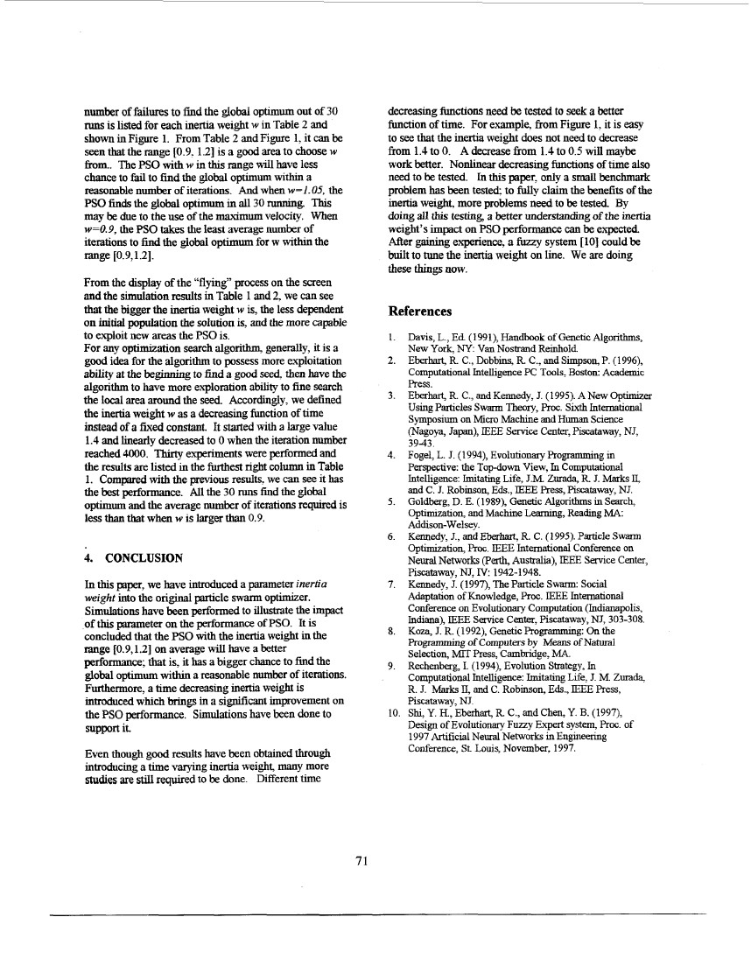
contributingto the change of the velocity of a particle.
Without these two parts, the particles will keep on
“flying”at the current speed in the same direction mtd
they hit the b u w PSO will not find a acceptableon .
solution unless there are acceptable solutions on their
“flying” trajectories. But that is a rare case. On the
other han4 refer to equation (la) without the first part.
Then the “flying” particles’ velocities are only
determined by their current positions and their best
positions in history. The velocity itself is memoryless.
Assume at the beginning, the particle i has the best
global position, then the particle z will be “Ylying”at the
velocity 0, that is, it will keep still until another particle
takes over the global best position. At the same time,
each other particle will be “flying”toward its weighted
centroid of its own best position and the global best
position of the population. As mentioned in [6], a
recommended choice for constant c1 and c2is integer 2
since it on average makes the weights for “social” and
“c0gniti0n’’ parts to be 1. Under t h s condition,the
particles statisticallycontract swarm to the current global
best position until another parhcle takes over from which
time all the particles statisticallycontract to the new
global best position. Therefore, it can be imagmed that
the search process for PSO without the frt part is ais
process where the search space statistically shrinks
through the generations. It resembles a local search
algorithm. This can be illuminated more clearly by
displaying the “flying” process on a screen. From the
screen, it can be easily seen that without the first part of
equation (la), all the particles will tend to move toward
the same position, that is, the search area is contracting
through the generations. Only when the global optimum
is within the initial search space, then there is a chance
for PSO to find the solution. The final solution is
heavily dependent on the initial seeds (population). So it
is more likely to exhibit a local search ability without the
first part. On the other hand, by adding the first part, the
parttcles have a tendency to expand the search space, that
is, they have the ability to explore the new area. So t h q
more likely have a global search ability by adding the
first part. Both the local search and global search will
benefit solving some kinds of problems. There is a
tradeoff between the global and local search For
different problems, there should be different balances
between the local search ability and global search ability.
Consideringof this, a inertia weight w is brought into the
equation (1) as shown in equation (2). This w plays the
role of balancing the global search and local search It
can be a positive constant or even a positive linear or
nonlinear function of time.
3. EXPERIMENTS AND DISCUSSION
In order to see the influence which the inertia weight has
on the PSO performance, the benchmark problem of
Schaffer’s f6 function [ 11 was adopted as a testing
problem since it is a well known problem and its global
optimum is known. The implementation of the PSO was
written in C and compiled using the Borland C++ 4.5
compilex. For the purpose of comparison, all the
simulations deploy the same parameter settings for the
PSO except the inertia weight w. The population size
(number of particles) is 20; the maxi” velocity is set
as 2; the dynamic range for all elements of a particle is
defined as (-100, loo), that is. the particle cannot move
out of this range in each dimension. For the SchafEer’s
f6 function the dimension is 2. So we display particles’
<‘flying”process on the computer screen to get a visual
understanding of the PSO performance; the maximum
number of iterations allowed is 4000. If PSO cannot
find a acceptable solution within 4000 iterations. it is
claimed that the PSO fails to find the global optimum in
this run.
~
Different inertia weights w have been chosen for
simulation For each selected w,thirty runs are
performed and the iterationsrequired for finding the
global optimum are recorded The results are listed in
Table 1. In Table 1,the empty cells indicate that the
PSO failed to ftnd the global optimum within 4000
iterationsin that running. For each w,the average
number of iterations required to &id the global optimum
is calculated and only the runs which find the global
optimum are used for calculating the average. For
example. when w=O.95, one run out of 30 failed to find
the global optimum, so only 29 run results are used to
calculate the average. The average number of iterations
for each w is listed at the bottom of the table 1. From
Table 1, it’s easy to see that when w is small (< OX), if
the PSO finds the global optimum. then it fitids it f s .at
Also from the display on the screen, we can see that all
the particles tend to move together quickly. This
confirms our discussion in the previous section that when
w is small. the PSO is more like a local search algorithm
If there is acceptable solution w t i the initial searchihn
space, then the PSO will find the global optimum
quickly, otherwise it will not find the global optimum.
When w is large (>1.2), the PSO is more like a global
search method and even more it always tries to exploit
the new areas. This is also illustratedby the “flying-’
display on the screen It is n t r l that the PSO will takeaua
more iterations to find the global optimum and have
more chances of failing to find the global optimum.
When w is medium (0.8<w<1.2).the PSO will have the
best chance to find the global optimum but also takes a
moderate number of iterations. For clearness. the
70
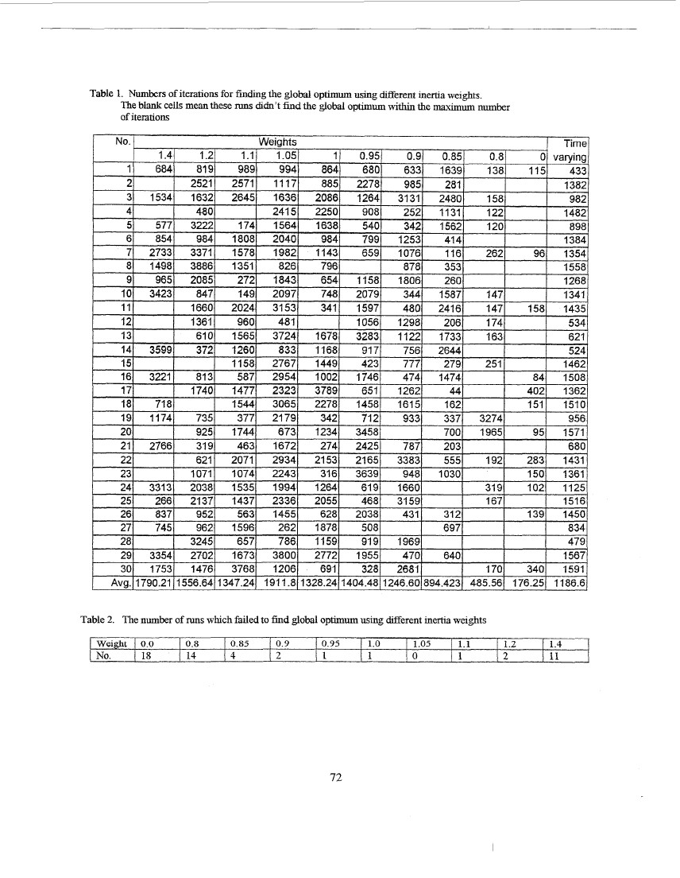
number of failuresto find the global optimum out of 30
runsis listed for each inertia weight w in Table 2 and
shown in Figure 1. From Table 2 and Figure 1 it canbe:
seen that the range r0.9. 1.21 is a good area to choose w
from.. The PSO with w in this range will have less
ihnchance to fail to find the global optimum w t i a
reasonable number of iterations. And when w=I.05, the
PSO finds the global optimum in all 30 running. This
may be due to the use of the maximum velocity. When
w=O.P, the PSO takes the least average number of
iterationsto find the global optimum for w within the
range [0.9,1.2].
From the display of the ‘‘flying’’process on the screen
and the simulationresults in Table 1 and 2. we can see
ta the bigger the inertia weight w is. the less dependentht
on initial population the solution is. and the more capable
to exploit new areas the PSO is.
For any optimization search algoritiuq generally, it is a
good idea for the algorithm to possess more exploitation
ability at the beginning to find a good seed then have the
algorithm to have more explorationability to tine search
the local area around the seed. Accordingly, we defined
the inertia weight w as a decreasingfunction of time
instead of a fixed constant. It started with a large value
1.4 and linearly decreasedto 0 when the iteration number
reached 4000. Thuty experiments were performed and
the results are listed in the furthest right column in Table
1. Compared with the previous results. we can see it has
the best performance. All the 30 runs find the global
optimum and the average number of iterationsrequired is
less than that when w is larger than 0.9.
4.
decreasingfunctions need be tested to seek a better
function of time. For example, from Figure 1, it is easy
to see that the inertia weight does not need to decrease
from 1.4 to 0. A decrease from 1.4 to 0.5;will maybe
work better. Nonlinear decreasing functions of time also
need to be tested. In this paper: only a snoall benchmark
problem has been tested: to fully claim t h benefits of the~
inertia weight, more problems need to be tested By
doing all this testing a better understanding of the inertia
weight’s impact on PSO performance can be expected
After gaining experience, a hzzy system [101 could be
built to tune the inertia weight on line. We are doing
these things now.
References
Davis, L., E d (1991), Handbook of Genetic Algorithms,
New York, NY:Van Nostrand Reinhold
2. Eberbart, R C., Dobbins, R C.2and simp so^ P. (1996),
Computational Intelligence PC Tools, Boston: Academic
Press.
3. Eberhart, R. C., and Kermedy, J. (1 995). ,4 New Optimizer
Using Particles Swarm TheoIy, Proc. Sixth International
Symposium on Micro Machine and H m m Science
(Nagoya, Japan), IEEE Service C n e ,Pkcataway, NJ?etr
3943.
4. Fogel, L. J. (1994), Evolutionary Programming in
Perspective: the Topdown View, In Contputational
Intelligence: Imitating Life, J.M. Zurada, R J. Marks Q
and C. J. Robinson, E&., EEE Press, Pismtaway, NJ.
5 . Goldberg, D. E. (1989), Genetic Algorithmsin Search
Optimization, and Machine Learning, Reading MA:
Addison-Welsey .
6. Kennedy, J., and Eberhart, R. C. (1 995). :Particle Swam
Optimization; Roc. IEEE International Conferenceon
Neural Networks (Path, Australia), IEEE Service Center,
Piscataway, NJ, N: 1942-1948.
7. Kennedy, J. (1997, The Particle Swann: Social
Adaptation of Knowledge, Roc. IEEE International
Conference on Evolutionaq Computation (Indianapolis,
Indiana), EEE Service Center, Piscataw;ty, NJ, 303-308.
8. Koza, J. R. (1992), Genetic Programming:On the
Programming of Computers by Means of Natural
Selection, MlT Press, Cambridge, MA.
9. Rechenberg, I. (1994), Evolution Strateg:y, In
J.ComputationalIntelligence: Imitating Lifee; M Z u r a h
R. J. Marks E, and C. Robinson, E&., IEEE Press,
Piscataway, NJ.
10. Shi, Y. H., Eberhart, R C., and Chen, Y. B. (1997),
Design of EvolutionaryFuzzy Expert sysrtem, Proc. of
1997 Artificial Neural Networks i Engineeringn
Conference, St. Louis, November, 1997.
1.
CONCLUSION
In this paper, we have introduced a parameter inertia
weight into the original particle swann optimizer.
Simulations have been performed to illustrate the h cpt
of this parameter on the performance of PSO. It is
concluded that the PSO with the inertia weight in the
range [0.9,1.2] on average will have a better
performance; that is, it has a bigger chance to find the
global optimum w t i a reasonable number of iterations.ihn
Furthermore, a time decreasing inertia weight is
introduced which brings i a significant improvement onn
the PSO performance. Simulations have been done to
support it.
Even though good results have been obtained through
introducing a time varymg inertia weight, many more
studies are still required to be done. Different time
71
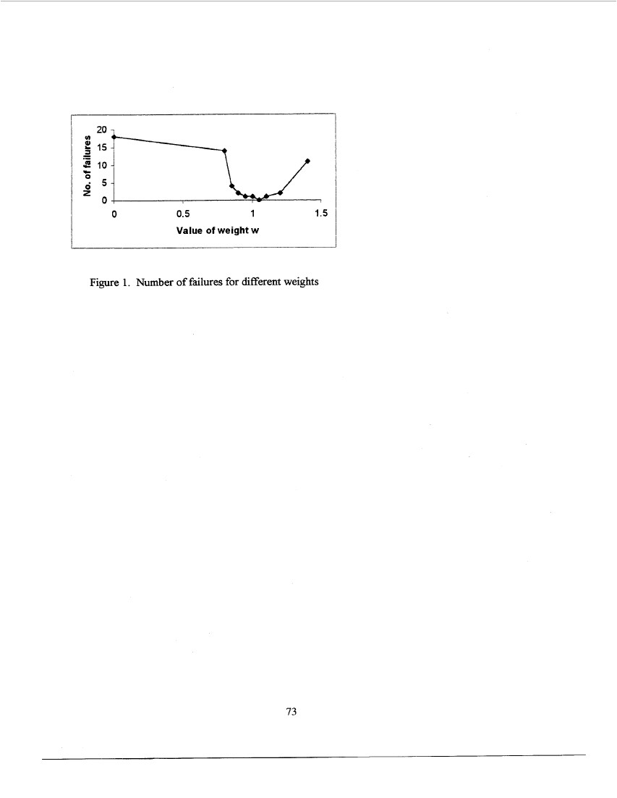
Table 1. Numbers of iterations for findingthe global optimum using different mertia weights.
The blank cells mean these runs didn't find the global optimum within the maximum number
of iterations
Table 2. The number of runs which failed to find global optimum using different inertia weights
weight
No.
I 0.0
1 18
I
I
0.8
I 0.85
(4
1 0.9
12
1 0.95
11
1
10.
I
1.05
I
1.1
I 1.2
12
I
14
11
10
(1
I
1.4
11
72
20 1
15
10
5
0
0
0.5
1
1.5
Value of weight w
Figure 1. Number of failures for different weights
73

